Our group have currently finished running PCA models for Poland and Hungary. PCA results for various subset selections of financial indices are quite different. We have doubt that whether our PCA implementation meets the requirement. Here we select representative selection results for two countries to show differences.

**Poland:**

(1)

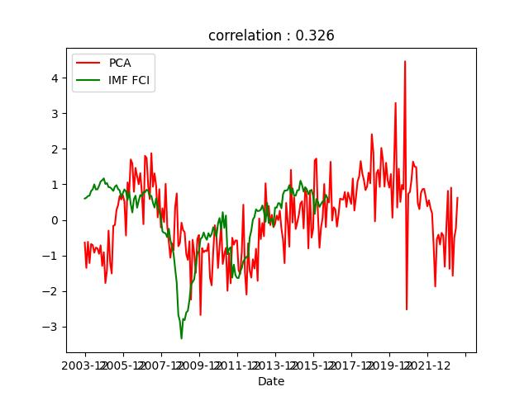

--------------------

id : 3230404519

corr_coef : 0.3255182669006096

explain variance ratio : 0.3374651117980625

Weight :

Term_Premium : 0.15036137076974687

Stock_Prices_mom%_change : 0.20989917395311372

Policy_Rate_&_Fed_Funds_Rate_Differential_AVG : 0.6670862622530027

Portfolio_Flows : 0.6988059198857439

(2)

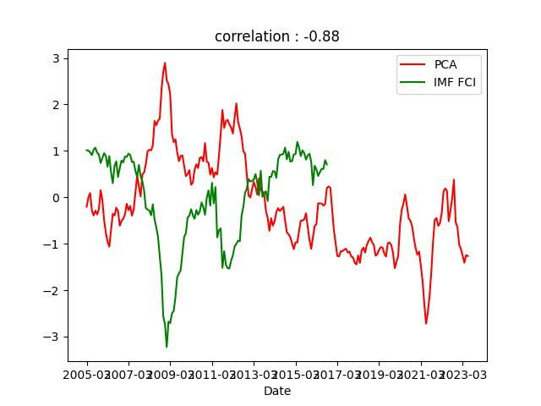

--------------------

id : 4146093033

corr_coef : -0.8800849274074956

explain variance ratio : 0.4440372574859956

Weight :

Risk_Premium : -0.6289585276560925

Stock_Prices_mom24mma%_change : -0.3819734717643226

Current_Account_Balance_over_GDP : -0.5298130581076461

Velocity_of_Money_mo12m%_change : -0.4216699666986188

The (1) PCA selection is the one with the highest correlation coefficient while the (2) PCA selection has the lowest correlation value. In the text description part below the PCA result plot, “Weight” represents elements in corresponding eigenvector for the result.

**Hungary:**

(1)

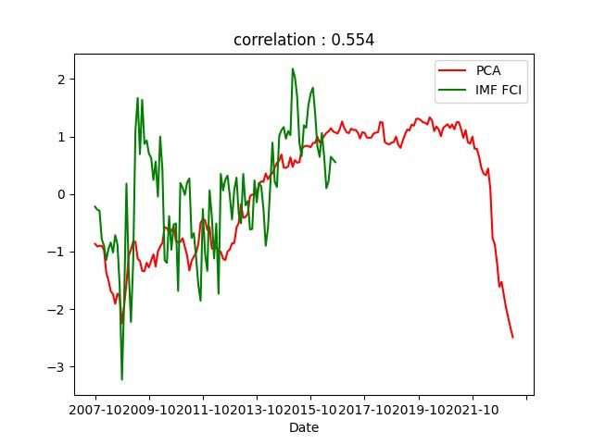

--------------------

id : 5645384571

corr_coef : 0.5537854514741996

explain variance ratio : 0.45716047624637707

Weight :

Term_Premium : 0.4874349090538897

Stock_Market_Volatility : 0.0028482971833536652

REER : 0.5209563651728428

One-Day_Repo_Rate_EOP : 0.5675678823791716

Bank_Lending_mo12m%_change : 0.3102675327988164

Foreign_Exchange_Reserve_over_GDP : 0.2694518866277244

(2)

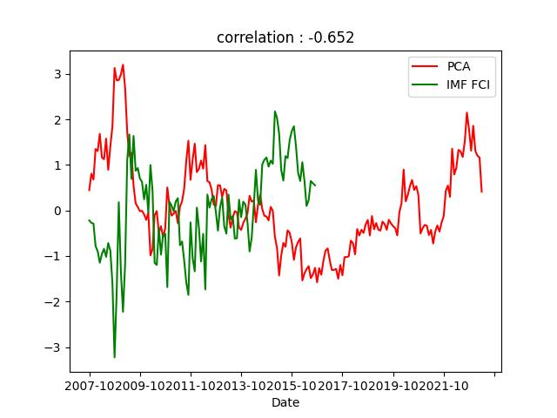

--------------------

id : 4877855988

corr_coef : -0.6519096304791531

explain variance ratio : 0.43381769181355045

Weight :

Risk_Premium : -0.4992663306618003

Stock_Prices_mom%_change : -0.324606731453407

Stock_Prices_mom24mma%_change : -0.6102487840473683

Current_Account_Balance_over_GDP : -0.5169921262626916

Bank_Lending_mo12m%_change : -0.07536022766504458

The (1) PCA selection is the one with the highest correlation coefficient while the (2) PCA selection has the lowest correlation value. In the text description part below the PCA result plot, “Weight” represents elements in corresponding eigenvector for the result.